**МИНОБРНАУКИ РОССИИ**

**САНКТ-ПЕТЕРБУРГСКИЙ ГОСУДАРСТВЕННЫЙ**

**ЭЛЕКТРОТЕХНИЧЕСКИЙ УНИВЕРСИТЕТ**

**“ЛЭТИ” ИМ. В.И УЛЬЯНОВА (ЛЕНИНА)**

**Кафедра МОЭВМ**

ОТЧЕТ

По практической работе

По дисциплине «Основы технологий хранения данных»

Тема: Запросы на языке SQL

Студент гр.6383 Базаров И

Преподаватель Борисенко К.А

Санкт-Петербург

2019

Ход Работы.

**База данных.**

Описание.

В данной базе данных представлена информация об интернет магазине.

EER Diagram

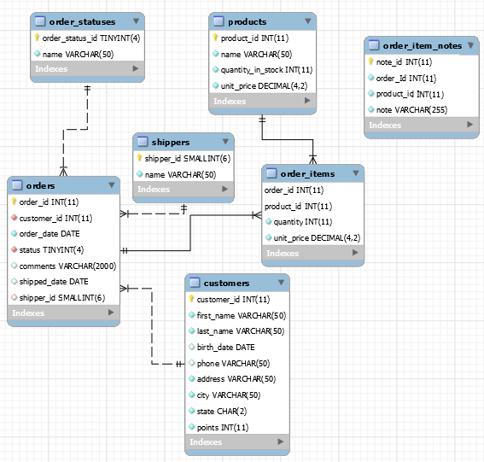

База данных содержит 7 таблиц.

Информация о данных, хранимых в таблицах, представлена в разделе Приложение

**Запросы**

1. /\*Select customers who are are\_not from one state \*/

SELECT \*

FROM customers

WHERE state != 'IL'

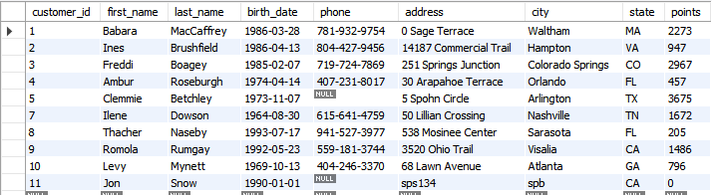

2Get the orders placed in 2018 year

SELECT \*

FROM orders

WHERE order\_date >= '2018-01-01'

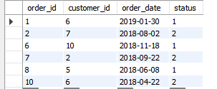

3Get the customers who are born before 1990 and have points more than 1000

SELECT \*

FROM customers

WHERE birth\_date > '1990-01-01' AND points > 1000

C:\Users\ilmb\Desktop\SQL Course Materials\query2.PNG

1. Get the customer name that starts with ‘b’

SELECT \*

FROM customers

WHERE last\_name regexp '^b'



1. Get the top 3 loyal customers(with top 3 points)

SELECT \*

FROM customers

ORDER BY points DESC

LIMIT 3



1. Determine each customer’s order id(who has orders)

SELECT order\_id,orders.customer\_id, first\_name, last\_name

FROM orders

INNER JOIN customers

ON orders.customer\_id = customers.customer\_id

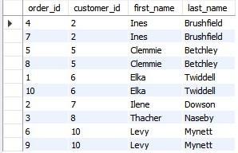

1. Status of each order

SELECT

o.order\_id, o.order\_date, c.first\_name, c.last\_name,

os.name AS status

FROM orders o

JOIN customers c

ON o.customer\_id = c.customer\_id

JOIN order\_statuses os

ON o.status = os.order\_status\_id

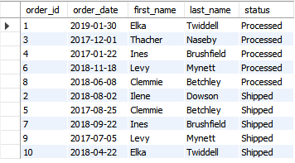

1. Get all customers order

SELECT

c.customer\_id,

c.first\_name,

o.order\_id

FROM customers c

LEFT JOIN orders o

ON c.customer\_id = o.customer\_id

ORDER BY c.customer\_id

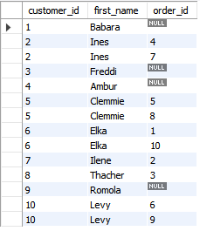

1. How many times each product has been ordered and its price for the current time

SELECT

p.product\_id,

p.name,

oi.quantity

FROM products p

LEFT JOIN order\_items oi

ON p.product\_id = oi.product\_id

**Вывод**

Практическая работа была выполнена на среде MySQL Workbench. Во время работы была создана база данных интернет магазина и созданы различные данные для получение информации.

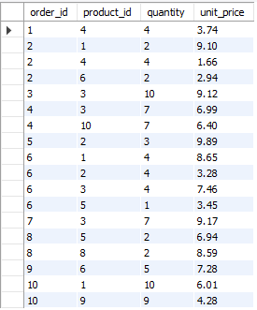

1. Get all orders and its shippers

SELECT

c.customer\_id,

c.first\_name,

o.order\_id,

sh.name AS shipper

FROM customers c

LEFT JOIN orders o

ON c.customer\_id = o.customer\_id

LEFT JOIN shippers sh

On o.shipper\_id = sh.shipper\_id

ORDER BY c.customer\_id

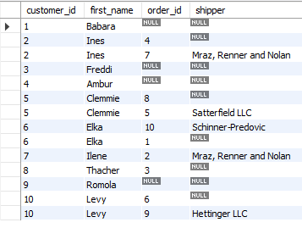

1. Add new customer to table

INSERT INTO customers

VALUES (DEFAULT, 'Jon', 'Snow','1990-01-01', null, 'sps134', 'spb', 'CA', default)

C:\Users\ilmb\Desktop\SQL Course Materials\query10.PNG

1. Get list of shippers what(products) then send

SELECT

sh.name AS shipper,

p.name AS product

FROM shippers sh, products p

ORDER BY sh.name

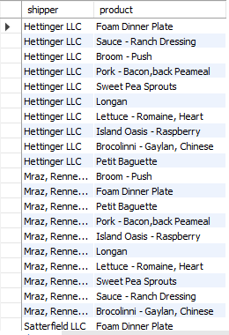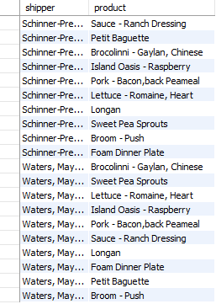

1. Update the comments or orders which has more than 3000 points

UPDATE orders

SET comments = 'gold customer'

WHERE customer\_id IN

(SELECT customer\_id

FROm customers

WHERE points >3000)

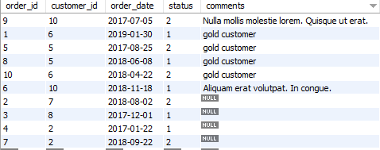

1. Get the orders that are not shipped

SELECT order\_id, customer\_id, status, shipped\_date, shipper\_id

FROM orders

WHERE shipper\_id IS NULL

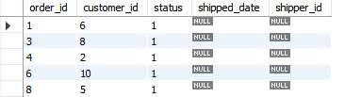

1. Get the orders placed in 2018 and higher

SELECT order\_id, customer\_id, order\_date, status

FROM orders

WHERE order\_date >= '2018-01-01'

ORDER BY order\_date

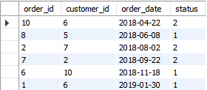

Приложение А

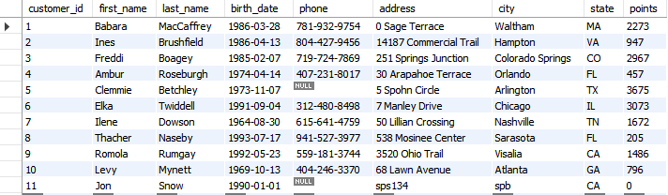

Table 1 : Customers

C:\Users\ilmb\Desktop\SQL Course Materials\order_item_notes.PNG

Table 2: Order item notes

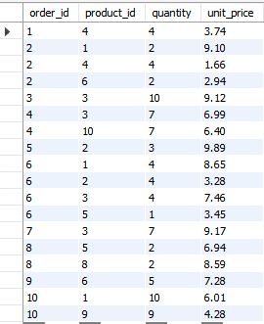

Table 3 : order items

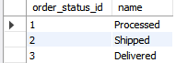

Table 4 : order statuses

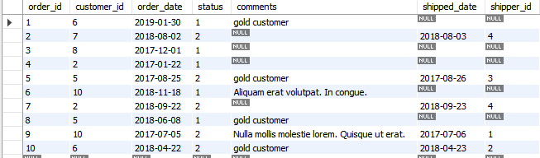

Table 5 : orders

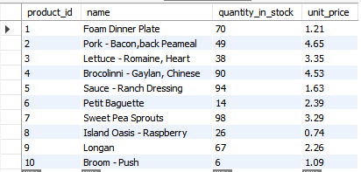

Table 6 : products

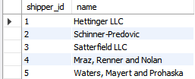

Table 7 : shippers